PROYEK SISTEM PENGISIAN KRS

DESAIN BASIS DATA



DISUSUN OLEH :

VIVI SISKA 145314061

NATALIA ARI CHRISMIYATI 145314064

IMANUEL DEMI PRASETYA 145314076

PROGRAM STUDI TEKNIK INFORMATIKA

FAKULTAS SAINS DAN TEKNOLOGI

UNIVERSITAS SANATA DHARMA

YOGYAKARTA

1. ER Diagram

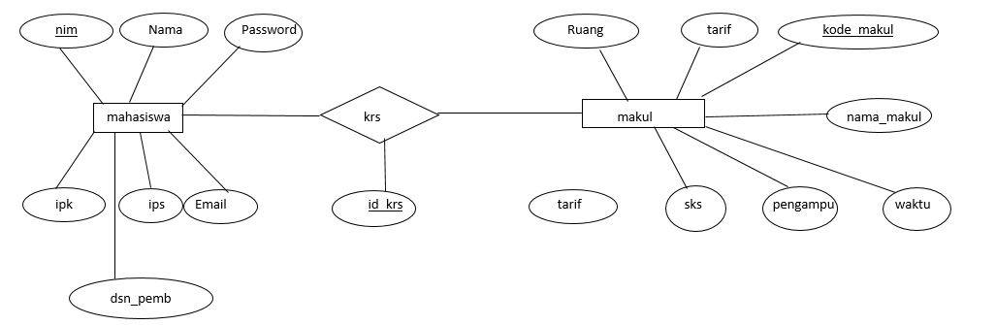

1. Physical design

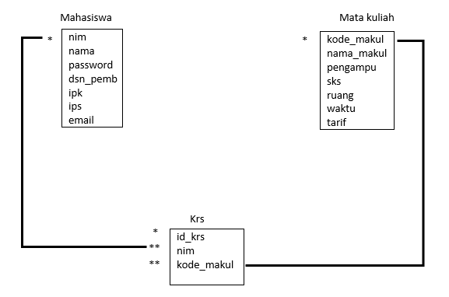

Tabel Mahasiswa

|  |  |  |  |  |  |  |
| --- | --- | --- | --- | --- | --- | --- |
| nim | nama | password | dsn_pemb | ipk | ips | email |
|  |  |  |  |  |  |  |
|  |  |  |  |  |  |  |

Tabel Mata Kuliah

|  |  |  |  |  |  |  |
| --- | --- | --- | --- | --- | --- | --- |
| kode_makul | nama_makul | pengampu | sks | ruang | waktu | tarif |
|  |  |  |  |  |  |  |
|  |  |  |  |  |  |  |

Tabel Krs

|  |  |  |
| --- | --- | --- |
| Id_krs | nim | Kode_makul |
|  |  |  |
|  |  |  |

1. Diagram Kelas
2. Mahasiswa.java

|  |
| --- |
| **Mahasiswa** |
| * password : String * nim : String * nama : String * email : String * dosen : String * ips : String * ipk : String * SKS : String |
| * getNim() : String * setNim(String) : void * getNama() : String * setNama(String) : void * getEmail() : String * setEmail(String) : void * getDosen() : String * setDosen(String) : void * getIps() : String * setIps(String) : void * getIpk() : String * setIpk(String) : void * getSKS() : String * setSKS(double) : void * createNim() : String |

1. MataKuliah.java

|  |
| --- |
| **MataKuliah** |
| * kodeMakul : String * namaMakul : String * waktu : String * sks : String * dosen : String * tarif : String * ruang : String |
| * getKodeMakul() : String * setKodeMakul(String) : void * getNamaMakul() : String * setNamaMakul(String) : void * getWaktu() : String * SetWaktu(String) : void * getSks() : String * setSks(String) : void * getDosen() : String * setDosen(String) : void * getTarif() : String * setTarif(String) : void * getRuang() : String * setRuang(String) : void |